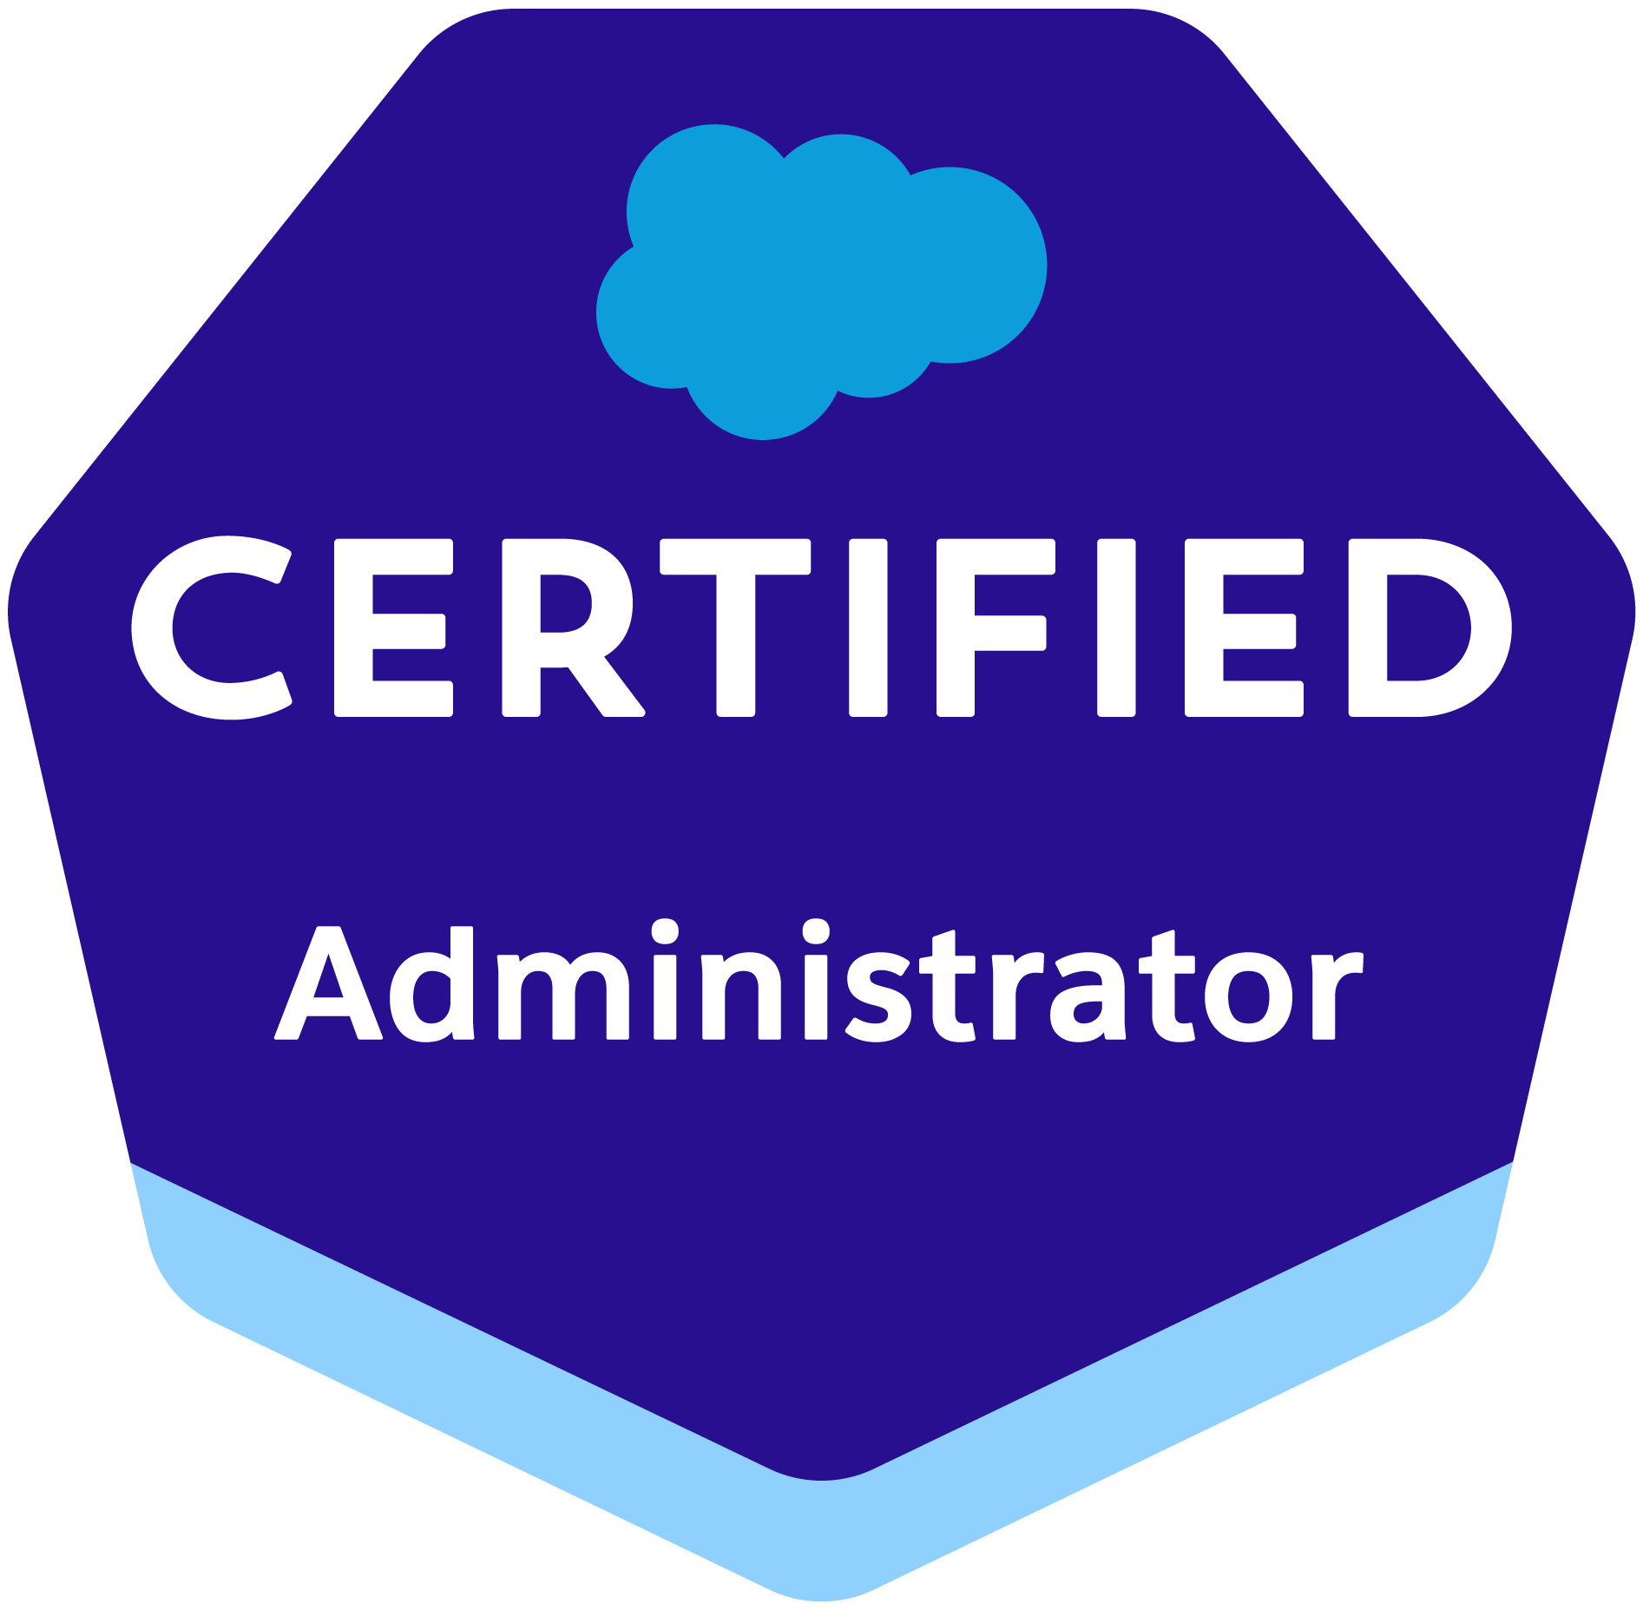 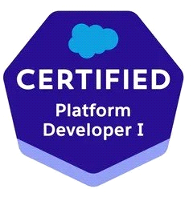 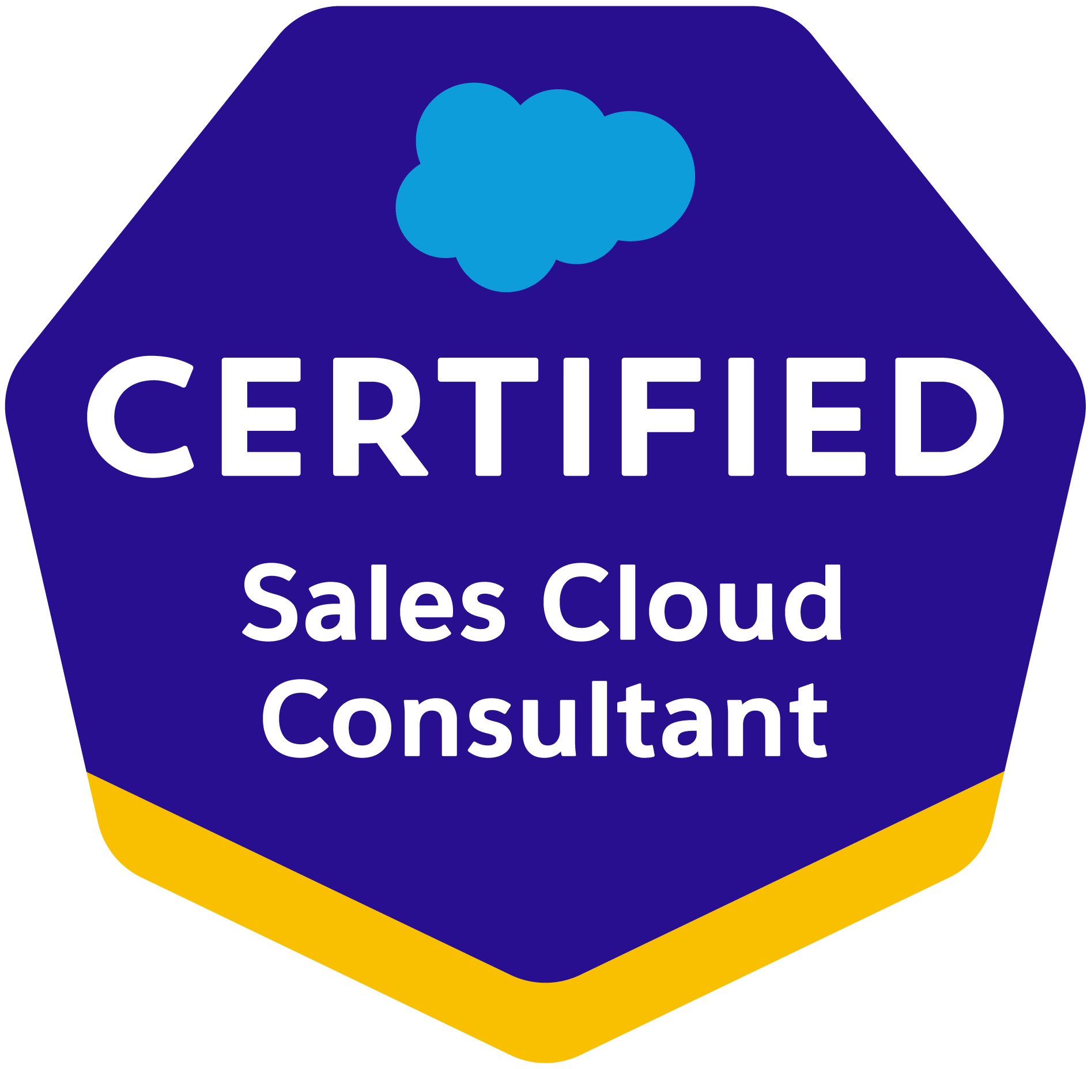 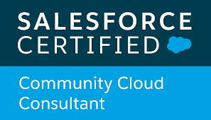 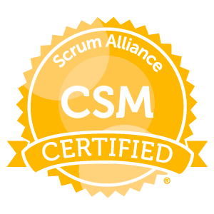

JOSEPH



Summary

* Professional with **10 + years** of experience in **Analysis**, **Design**, **Development**, **Testing**, **Delivery** and **Production Support** of application software. Over **8+ years** of experience in **Salesforce.com CRM Platform and Apex technologies, Sales Cloud, Service Cloud, Financial Force** and **Experience Cloud.**
* Expertise in **Development**, **Administration, Configuration, Requirements gathering, Implementation, Integration** and **Support of Salesforce CRM and Salesforce applications**.
* Worked in Production support roles providing support in **Aura Framework, Lightning Components, Lightning Web Components** and **Salesforce Lightning Design System** (SLDS).
* Provided support for Apps upgraded from Salesforce Classic to **Lightning Experience** to develop a rich user interface and better interaction of pages.
* Designed and executed comprehensive **omnichannel** strategies that seamlessly integrated online and offline customer touchpoints, resulting in improved customer engagement and increased sales.
* Ability to analyze **Sales Data** and generate **Reports and Dashboards** providing valuable insights to sales teams and management.
* Excellent communication and collaboration skills, working closely with cross-functional teams to gather requirements, design solutions, and deliver Salesforce implementations.
* Expertise in building VisualForce Pages, Visual force Custom Controllers, Components, Custom Objects, Reports, Dashboards, Tabs and Customer communities, Analytic Snapshots, Process Builders and Flows.
* Have hands-on experience on **Email to Case, Web to Case, Case Assignment rules, Escalation rules.**
* **Salesforce Development Life Cycle implementation** covering **Sales Cloud**, **Service Cloud**, Call Center, Chatter and App-exchange applications.
* Worked on **Visualforce pages** and had experience with **CSS and Java Script.**
* Experience in querying salesforce.com database using **SOQL & SOSL** queries using Force.com Explorer.
* Working intensively with the **Sales Cloud, Service Cloud, Health Cloud and Communities** for creating different applications and their business process for optimization.
* Working Knowledge of **Sales Cloud, Service Cloud and Communities**. Consistently Applying learned processes, procedures, and workflows to include (however not limited to) the software development lifecycle and/or release processes.
* Experience in working with **Eclipse IDE** and **VS Code** with Force.com Plug-in environment for writing Business logic in Apex Programming Language**.**
* Experienced in **JIRA** and **JAAS** in bug tracking, issue workflow, Labeling, linking issues and in creating projects and story points.
* Work in the Salesforce.com development environment which includes custom objects, workflows, triggers, migration tools, SOQL and REST-based web services using **Apex programming, Lightning web components (LWC), and related technology components.**
* Providing system administration and customization support of internal and customer-facing Salesforce environments, especially related to customized applications including **Apex, LWC, Visualforce and lightning components, user permissions, security settings, process builders, visual flow, custom objects, and validation rules.**
* Experienced working with various **AppExchange** products.
* Experience in implementing security and sharing rules at object, field, and record level for different users at different levels of organization. Also created various profiles, Permission Sets, Role Hierarchy and configured the permissions based on the organizational hierarchy.
* Experience in data migration using **Import wizard and Apex Data Loader**.
* **Data Load** for SFDC standard objects, custom objects.
* Used different data tools like **Apex Data Loader, Excel Connector, Import Wizard, SFDC Data Export, Mass Delete** etc.
* Experience in installing Salesforce **AppExchange Apps**, configured, and maintained user security permissions in compliance with organizational needs.
* Experience in data migration from **Excel, MS outlook and Legacy Systems using Data Loader, Import Wizard**.
* Designed and developed **SOAP** and **REST** based web services to integrate Salesforce with different external systems, experience in **MuleSoft integration**.
* Hands-on experience with **Bulk API, Rest API, Soap API, XML.**
* **VS Code IDE** for writing business logic in Apex programming language.
* **WSDL, SOAP API, REST API, Call Outs, Batch** and **Schedule Apex programs.**
* Expertise in using **Checkmarx's Apex Code Scanner** for identifying and mitigating security vulnerabilities in Salesforce Apex code.
* Expertise in utilizing **Salesforce Audit Trail** to track and monitor user activities, changes, and

**security-related events** within the Salesforce platform.

* Used Salesforce Audit Trail to maintain **data governance** and compliance with regulatory requirements by **monitoring data access, modifications**, and **data export activities**.
* Ability to set up real-time alerts or notifications based on specific audit events, allowing the team to promptly respond to critical activities.
* Strong knowledge & experience in **monitoring user activities**, **including login history**, **session duration**, and **access patterns**, to ensure secure user behavior and adherence to company policies.
* knowledge of data encryption techniques within Salesforce, including fields, files, and data at rest, ensuring that sensitive information remains protected.
* Experience in setting up **object and field-level security permissions** to restrict user access to specific records and fields containing sensitive information.
* Employed validation rules to enforce data quality and ensure that data entered into **Salesforce meets specific security** and business requirements.
* Expertise in implementing **Salesforce Data Security** by designing robust data security measures within Salesforce to protect sensitive information and ensure compliance with regulations.
* Monitoring **trust.salesforce.com** to check the status, security, compliance, and availability of Sandboxes.
* Strong knowledge & experience working in teams implementing **Agile Methodologies.**
* Analyzed problematic areas to provide recommendations and solutions.
* Determined areas for improvement and implemented processes to alleviate problems.
* Developed **custom solutions based upon clients' strict requirements.**
* Troubleshoot issues by understanding issues, diagnosing root causes, and coming up with effective solutions.

Professional Certifications

* **Platform Developer I** certified from Salesforce.
* **Salesforce Certified Administrator**
* Salesforce Certified **Sales Cloud Consultant**
* Salesforce Certified **Community Cloud Consultant**
* Certified Scrum Master (CSM)

Technical Skills

|  |  |
| --- | --- |
| Salesforce CRM | Apex Language (Classes, Trigger, Batch, Schedule), SOQL & SOSL Language, Visualforce Pages, Components, Sales Cloud, Service Cloud, Salesforce Community Cloud Ant based Force.com Migration Tool, Workflow rules, Process builders, Flows, Approval Process, Profiles, Permission Sets, Role Hierarchy, Validation Rules, Custom objects, Relationships, Page Layouts, Search Layouts, Record Types, Reports, Dashboards. |
| Force.com Tools | Developer Console, Force.Com IDE, Force.Com Explorer, Workbench, Data Loader, Lightning, Integration, Salesforce Connector. |
| Other Programming Languages | JavaScript, HTML, XML, DHTML, SQL |
| Version Control Systems | BitBucket, GitHub. |
| Domain | Healthcare, Energy, Sports, Retail, Services |

Work Experience

**Employer: Mastercard**

**Client: Ethoca Dec’22 –Present Role: Sr. Salesforce Consultant Location: St. Louis, Missouri**

* Worked on **Implementing Community Cloud**, used JavaScript to design custom buttons and used **HTML, CSS, Apex class** to build **custom Pages**. Wrote various **triggers** to consolidate all the screens together with the required workflow and covered all the Apex classes with the **test coverage** as required.
* Used **Data Loader**, **workbench** to insert, update, and bulk import or export of data from Salesforce Objects.
* Extensively exposed to creating **Objects, Fields, Page Layouts Record Types, Workflows, Approval Processes, Escalation Rules, Assignment Rules, Validation Rules, Email Services, Data Migration activities, Roles, Profiles,** and other standard functionalities.
* Created **Formula fields, validation rules, approvals** for the flexibility and functionality of force platform application.
* Customized the Salesforce.com applications by including **custom tabs** to make Salesforce CRM more relevant to the business.
* Designed and implemented **Flows** to meet to the needs of the application.
* Created **related lists** and other components on record detail and edit pages.
* Used **Data Loader** for data management in force.com platform.
* Expertise in implementing **Salesforce Data Security** by designing robust data security measures within Salesforce to protect sensitive information and ensure compliance with regulations.
* Configured **field-level security** settings to restrict user access to specific fields containing sensitive data, ensuring that only authorized users can view or modify such information.
* Reviewed various other changes and also mentored other team members.
* Writing high-quality code to program complete applications on schedule.
* Involved in **Requirements gathering** from the initial phase of the project.
* Analyzing the **user requirements & estimating the work hours sprint wise**.
* Optimized the code and process to make the products robust.

**Employer: Deloitte**

**Client: British American Tobacco Feb’22 – Oct’22 Role: Sr. Salesforce Consultant**

**Location: Hyderabad, India**

* Designed, developed **Apex classes, controller classes** and **Apex triggers** for various functional needs in the application.
* Created **workflow rules** and defined related tasks, time triggered tasks, email alerts, field.

updates to implement business logic.

* Implementation of complex business logic using **Apex and visual force**.
* Created **Unit Test classes** for Apex classes and triggers.
* Created **Formula fields, validation rules, approvals** for the flexibility and functionality of force platform application.
* Customized the Salesforce.com applications by including **custom tabs** to make Salesforce CRM more relevant to the business.
* Designed and implemented **Custom objects, Page layouts, Custom tabs, and Components** to meet the needs of the application.
* Created **related lists** and other components on record detail and edit pages.
* Used **Data Loader** for data management in force.com platform.
* Leading a team of 10 and also responsible for effective communication between the clients and development team.
* Reviewed various other changes and also mentored other team members.
* Writing high-quality code to program complete applications on schedule.
* Involved in **Requirements gathering** from the initial phase of the project.
* Analyzing the **user requirements & estimating the work hours sprint wise**.
* Optimized the code and process to make the products robust.

**Employer: Mindtree Limited Client: EA Sports Nov’20 – Nov’21 Role: Sr. Salesforce Consultant Location: Hyderabad, India**

* Involved in system integration using **Callouts, Triggers, and web service**s.
* Worked on **APEX** programming with java script.
* Designed, and developed **Apex classes, Apex Triggers** for various functional needs in the application.
* Designed **VisualForce pages** with XML, HTML along with custom controllers and controller extensions.
* Designed custom components, used them in VisualForce pages along with **AJAX** for partial page refresh.
* Imported accounts and contacts data through **Import Wizard**.
* Worked on data migration from databases to SFDC using **Data Loader.**
* Handled peer-peer code review activities for all the team members.
* Participated in development, coding and **SOQL complex queries** as per business logic.
* Creating High Level Design Documents & Technical Design Documents.
* Performing Performance checks of the developed solution.

**Employer: EPAM Systems**

**Client: CLEAResult(CLR-DSMT) Jul’17 – Jul’20 Role: Sr. Salesforce Consultant**

**Location: Atlanta, Georgia**

* Worked on **Implementing Community Cloud** using **Apex class** to build **custom Pages**. Wrote various **triggers** to consolidate all the screens together with the required workflow and covered all the Apex classes with the **test coverage** as required.
* Used version control systems such as Azure DevOps, GitHub.
* Used Force.com IDE for development of **Visual Force Pages**, **Apex classes, Triggers** and debugging and analyzing logs.
* Worked extensively with the QA team designing test plans and test cases for the User Acceptance testing (UAT).
* Extensively exposed to creating **Objects, Fields, Page Layouts Record Types, Workflows, Approval Processes, Escalation Rules, Assignment Rules, Validation Rules, Email Services, Data Migration activities, Roles, Profiles,** and other standard functionalities.
* Extensive knowledge about **Salesforce Setup menu, Configuration, Custom Application Development, Administration, Data Migration and Deployment** of applications to **Force.com platform**.
* Work in the Salesforce.com development environment which includes custom objects, workflows, triggers, migration tools, **SOQL** and **REST-based web services** using Apex programming, Lightning web components (LWC), and related technology components.
* Experience in creating custom objects and custom fields in Lightning experience. Expertise in Lightning app builder and implemented new applications based on Lightning to have compatibility of the app in mobile, Tab and Desktop versions.
* Experienced in implementing **Apex Triggers, Visualforce pages, Apex class, Web Service, JavaScript, XML, HTML** to achieve complex business functionalities.
* Worked effectively to ensure that the data is protected and is made available to the authorized Portal Community users by customizing the user **Roles, Profiles, Permission Sets, Field Accessibility and Sharing Rules.**
* Customized logging screens and landing screens of the community by creating **Visualforce pages, Custom Controllers.**
* Attending daily **AGILE SCRUM** meetings and updating the status on a day-day basis with what is done and what has to be done. Gave various training sessions to onboard new engineers to the team.

**Employer: EPAM Systems Client: Sanofi Sep’16 – Jun’17 Role: Salesforce Consultant Location: Hyderabad, India**

* Customize Salesforce and **Vlocity applications** to meet the specific needs of the industry and

the client. This includes creating custom objects, fields, workflows, validation rules, and page layouts.

* Hands on Experience in working on **force.com** developer toolkit including **Visualforce pages, Apex classes, Apex controllers and Apex triggers** to develop custom business logic.
* **Integration Methodologies**, different **API, Trigger framework**, **Recursive Triggers**, **VF Remoting, Asynchronous Framework** & options.
* Worked on the **Visualforce page enhancements** as part of UI overhaul of the company’s website.
* Worked on UI tasks of the company’s website by developing **Lightning Components**.
* Responsible for classic to **lightning migration** of the existing **Visualforce pages/classic content**.
* Implemented **Salesforce Sales Cloud & Salesforce Communities, Sites** for business support.
* Working with **Administration activities like Users, Profiles, Permission Set Role, OWD settings and**
* **Sharing Rules. Designed and Developed Sales Cloud, Communities, Sites, and Integration**.
* Proficiency in **designing, administering, and configuring** Salesforce features including **Profiles, Roles, Users, Page Layouts, Workflows, Reports, Dashboards.**
* Ability to quickly understand business/functional requirements and apply **Salesforce business logic** to solve problems.
* I have good experience in designing Front-end using Dynamic **Visual force pages, Components, HTML 5, CSS 3, JavaScript, jQuery, Bootstrap, Media Queries, AJAX**.
* Implemented Salesforce Development Cycle covering **Sales Cloud, Service Cloud, Call Center, Chatter & App-exchange applications.**
* Worked on Sales Cloud with Accounts, Contacts, Cases and Solutions to generate towards developing business.
* Used **Agile and Scrum Methodology** for developing Application.
* Involved in **defect analysis and creating test metrics** for three releases of the project • Involved in **Salesforce.com Application Setup** activities and customized the applications to match the functional needs of the organization.
* Performed the role of support engineer for the internal users and helped them in getting used to the application, generated **reports,** and saved them for further access to the users. • Worked on the **Salesforce1 Platform** to build Mobile App by enabling Lightning Components to make Lightning Application mobile.
* Used **Metadata API** to retrieve, deploy, create, update, or delete customization information(such as custom object definitions and page layouts)
* Deployment/Continuous Integration experience through **GITHUB, ANT**
* Well versed with **Test Documentation** (Test Scenarios, Test Cases, Test Data, and Defect Report & Test Metrics).
* Involved in Development of **Test plans, Test Execution, S/W Verification and Defect Management.**
* Experience with managing the complex Data Experience in Integrating AppExchange Applications with **Salesforce, Mass EMail Management, Application management using Force.com Plug-in & Eclipse IDE** in Sandbox and Production Environments, working with different aspects of **Web Services (XML, WSDL, SOAP, REST, SSI) & web integration with SFDC**.
* Expert in developing **Custom Applications, Custom objects, Custom fields, Custom Tabs, Custom components, and Role based page layouts**.
* Created **Public Groups, Queues, Permission Sets, Profiles, Users & Security Settings** based on role hierarchy. Involved in **Data Migration** from three Legacy Systems to Salesforce.
* Worked with **SOQL, SOSL** queries with **Governor Limitations** to store and download the data from Salesforce.com platform database.
* Specially worked on Case Management with **Workflow** and **Approval Process**, **User Entitlements and Role hierarchy for Salesforce.com Applications. Implemented Field Level Security** for sensitive data

holder fields.

* Worked on writing **Apex Triggers Apex Classes, Batch Apex and Scheduled Apex**.
* Experience in designing UI using **Visual Force Pages**. Wrote Test Scripts for various scenarios.
* **Migrating Metadata** from one sandbox to another sandbox using **Force.com IDE** tool.

**Employer: Persistent Systems**

**Client: Aditya Birla, India Oct’15 – Aug’16 Role: Salesforce Consultant**

**Location: Hyderabad, India**

* Created **Visualforce pages, Apex Triggers, Apex Classes, Test Methods, and Workflows**.
* Worked on **Salesforce.com Sales Cloud functionality, including Account Planning, Sales Forecasting, Opportunity Management and Lead Management.**
* Developed **SOQL** query to pull data from salesforce.com
* Deploy using **Force.com IDE tool, Changesets & Eclipse** for the sandbox to production environments.
* Developed integrations to Integrate Data from Salesforce.com using **SFDC APIs**.
* Created **Page Layouts to organize Fields, Custom Links, Related Lists,** and other **components** on

**Record Pages**.

* Implemented various advanced fields like **Picklist Fields, Master-Detail Fields, Custom Formula Fields, and defined Field Dependencies for custom Picklist fields**.
* Implemented **Case Assignment Rules** to direct the case to appropriate groups.
* Wrote **Case Escalation Rules** to escalate cases depending on timeframe and difficulty of case issues.

**Employer: IMS Health**

**Client: Endo-Paladin, India Oct’14 – Sep’15 Role: Salesforce Consultant**

**Location: Bangalore, India**

* Developed **Apex Classes, Visualforce Pages** and done **deployments**.
* Created **Reports** and **Dashboards**.
* Involved in **Unit Testing** and **Test Coverage for apex classes and triggers**.
* Created the **Validation Rules, Approval Process, Workflows and Email Alerts**.
* Designed and developed **Apex Triggers** for various functional needs in the application.
* Deploy using **Force.com IDE tool, Changesets & Eclipse** for the sandbox to production environments.

**Employer: Anode Technologies**

**Client: Endo-Paladin, India Mar’13 – Sep’14 Role: Salesforce Consultant**

**Location: Hyderabad, India**

* Developed **Apex Classes, Visualforce Pages** and done **deployments**.
* Created **Reports** and **Dashboards**.
* Involved in **Unit Testing** and **Test Coverage for apex classes and triggers**.
* Created the **Validation Rules, Approval Process, Workflows and Email Alerts**.
* Designed and developed **Apex Triggers** for various functional needs in the application.
* Deploy using **Force.com IDE tool, Changesets & Eclipse** for the sandbox to production environments.

Education

**Name of the Education Establishment:** Hindustan University - Chennai

**Degree:** Master (ME), June-2011

**Specialty:** Computer Science Engineering

**Name of the Education Establishment:** JAWAHARLAL NEHRU TECHNOLOGICAL UNIVERSITY - Hyderabad

**Degree:** Bachelor (BTech) , April-2008

**Specialty:** Computer Science Engineering